|  |
| --- |
| **4-BIT ALU** |
|  |
| ***DE Lab Project Report*** |
| ***Submitted By*** |
| **Bhargav-18BCS3542**  **Huzefa- 18BCS3554** |
| ***Under the Guidance of*** |
| **Mr. Anshul Sharma**  **Mr. Divneet Singh Kapoor**  **Mr. Khushal Thakur** |
| **Assistant Professors, Academic Unit – 1** |
|  |
| **Academic Unit-1**  **Chandigarh University** |

**Table of Contents**

1. Problem Identification .......................................................................................................... 1

2. Features................................................................................................................................. 2

3. Design Flow ......................................................................................................................... 3

4. Outcome ............................................................................................................................... 4

5. Cost Analysis ........................................................................................................................ 6

7. Product Catalogue ................................................................................................................ 7

1. **Problem Identification**

To create a ALU using gates which can perform 4 bit calculation such as addition , subtraction etc.

**2. Features**

**Capabilities:**

● Addition - 4 bit binary addition of two numbers.

● Subtraction - 4 bit subtraction of two numbers in binary form.

**3. Design Flow**

# Block Diagram

|  |  |  |  |  |  |  |
| --- | --- | --- | --- | --- | --- | --- |
| Input  signal |  | ALU |  | Seven  Segment  Decoder |  | Seven  Segment  Display |

**4.Circuit Diagram :**

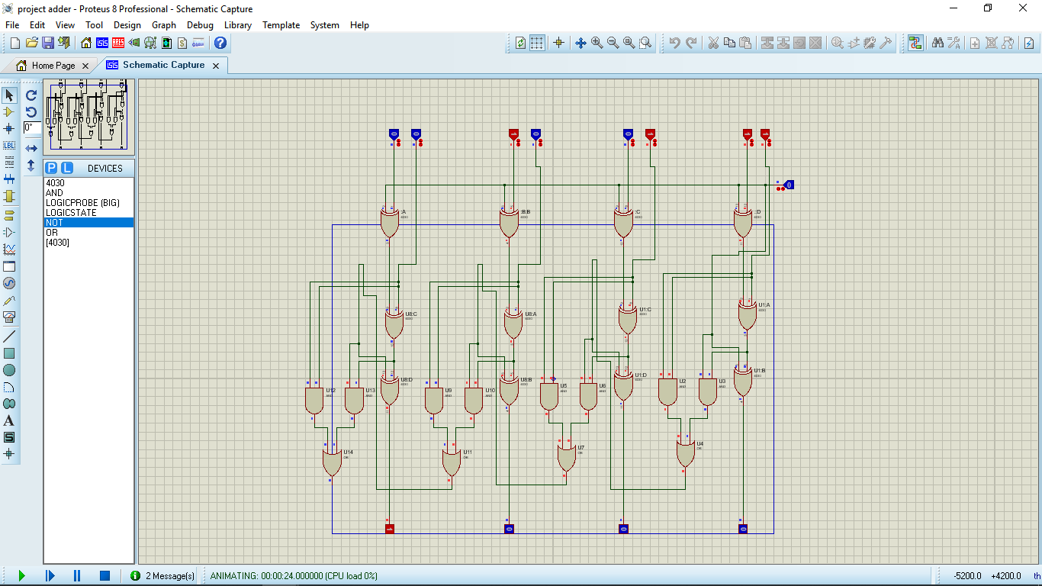

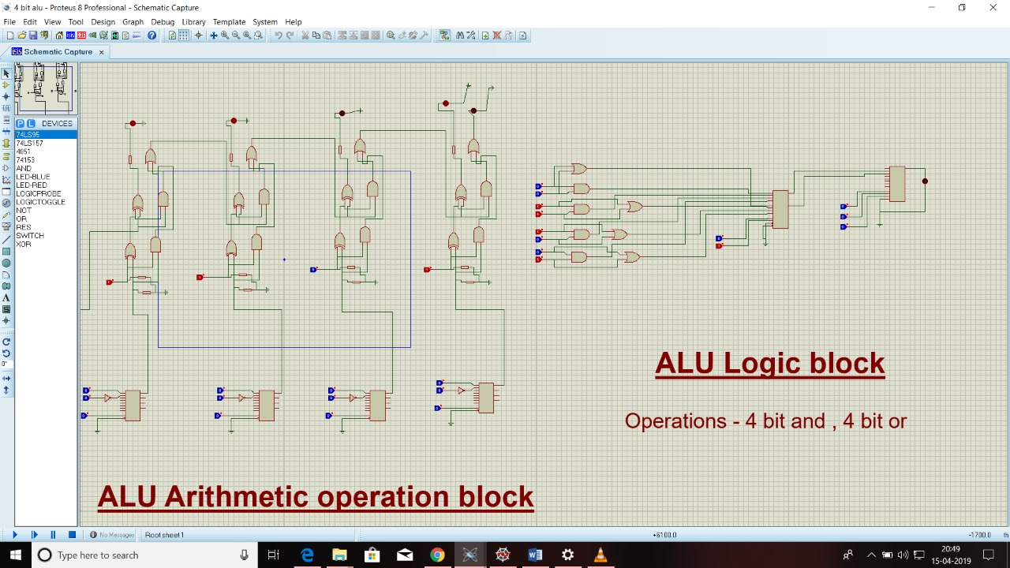

# Materials:

|  |  |
| --- | --- |
| Sr. No. | Component |
| 1 | 7408(And gate) |
| 2 | 7432(Or gate) |
| 3 | 7486(Xor gate) |
| 4 | 7404(Not gate) |
| 5 | Logic probe |
| 6 | Logic identifier |
|  |  |

**5. Outcome**

**6. Cost Analysis**

No cost.